Name: YI XU

Email: y.xu0520223@arts.ac.uk

**Creative Making 3**

**Final Project**

**Project Title: 「Spirituality」**

**Video:**

https://youtu.be/YyTjQYZJYJc

**GitHub:**

<https://github.com/YIXU22035611/Creative-Making_Final.git>

**Project Description:**

"Long ago, when people were still straight to their spiritual nature, there was unimpeded communication with animals and plants." In the New Age movement, emphasis is placed on the harmonious relationship that humans had with all things natural in ancient times, and the high level of spiritual ability that humans once possessed.

I created the game of the same name, Spirituality, with the hope that through this game, humanity will return to the spiritual age and regain the ability to connect with the planet through interaction with Spirit, both in the game and in reality.

The first part of the game is Spiritual Awakening, and I have used hand-drawings on the rock walls to show the concept of the game through ancient legends. At the same time, the physical device of "Spirit" will gradually awaken.

The second part of the game is Cosmic Consciousness, which I designed with reference to energy therapy. The player adjusts his energy frequency with reference to the rhythm of plants in the scene, and establishes a connection with the universe by controlling the "orchid grass" that represents him.

The third part is Ecospirituality. After establishing a connection with the universe, the player can try to get closer to the plants along the way and feel their thoughts.

The fourth part is Spiritual Connection, when the player stands at the end of the game, the "spirit" of the real world will wake up and interact with the player, as the climax and the end of the game.

Finally, I try to use this work to call for reverence for the source of our life, to reflect on anthropocentrism and advocate biocentrism, and to explore and recognise "consciousness".

**5 images：**

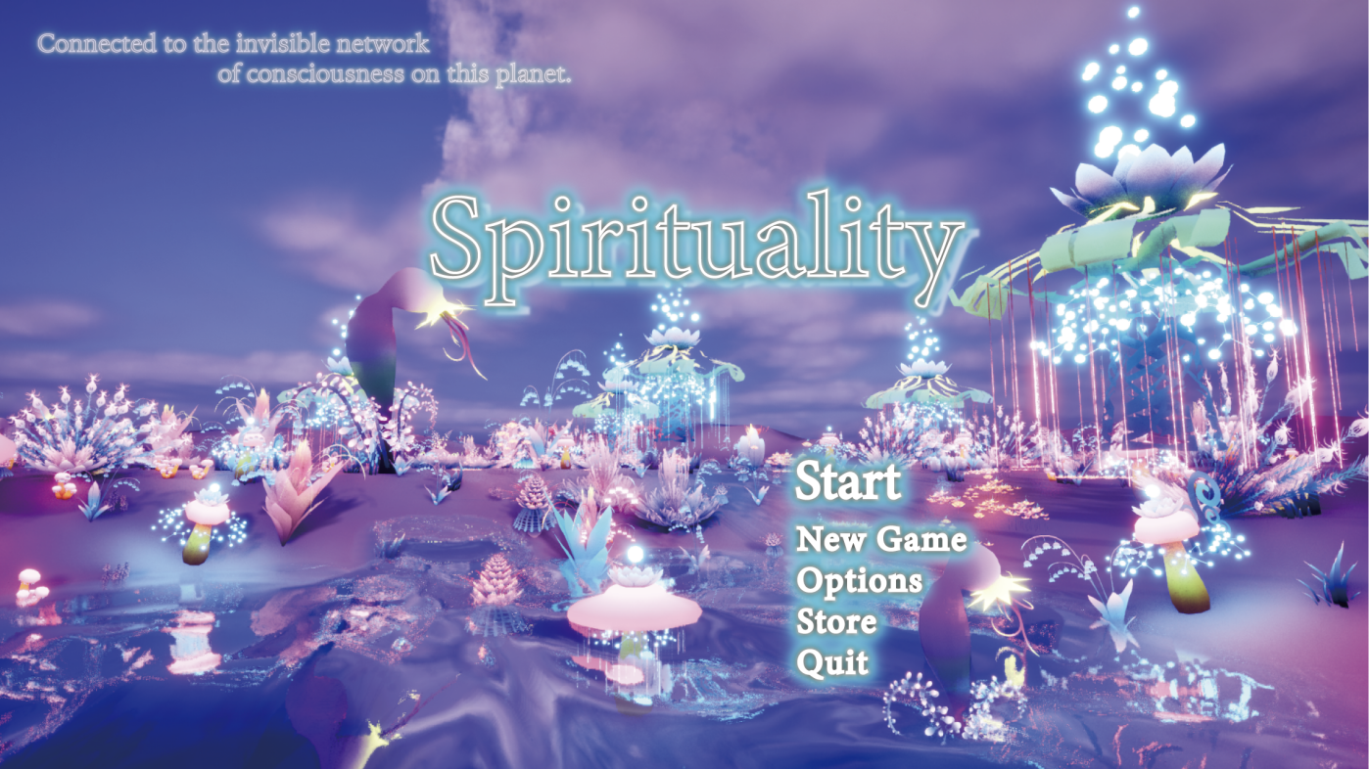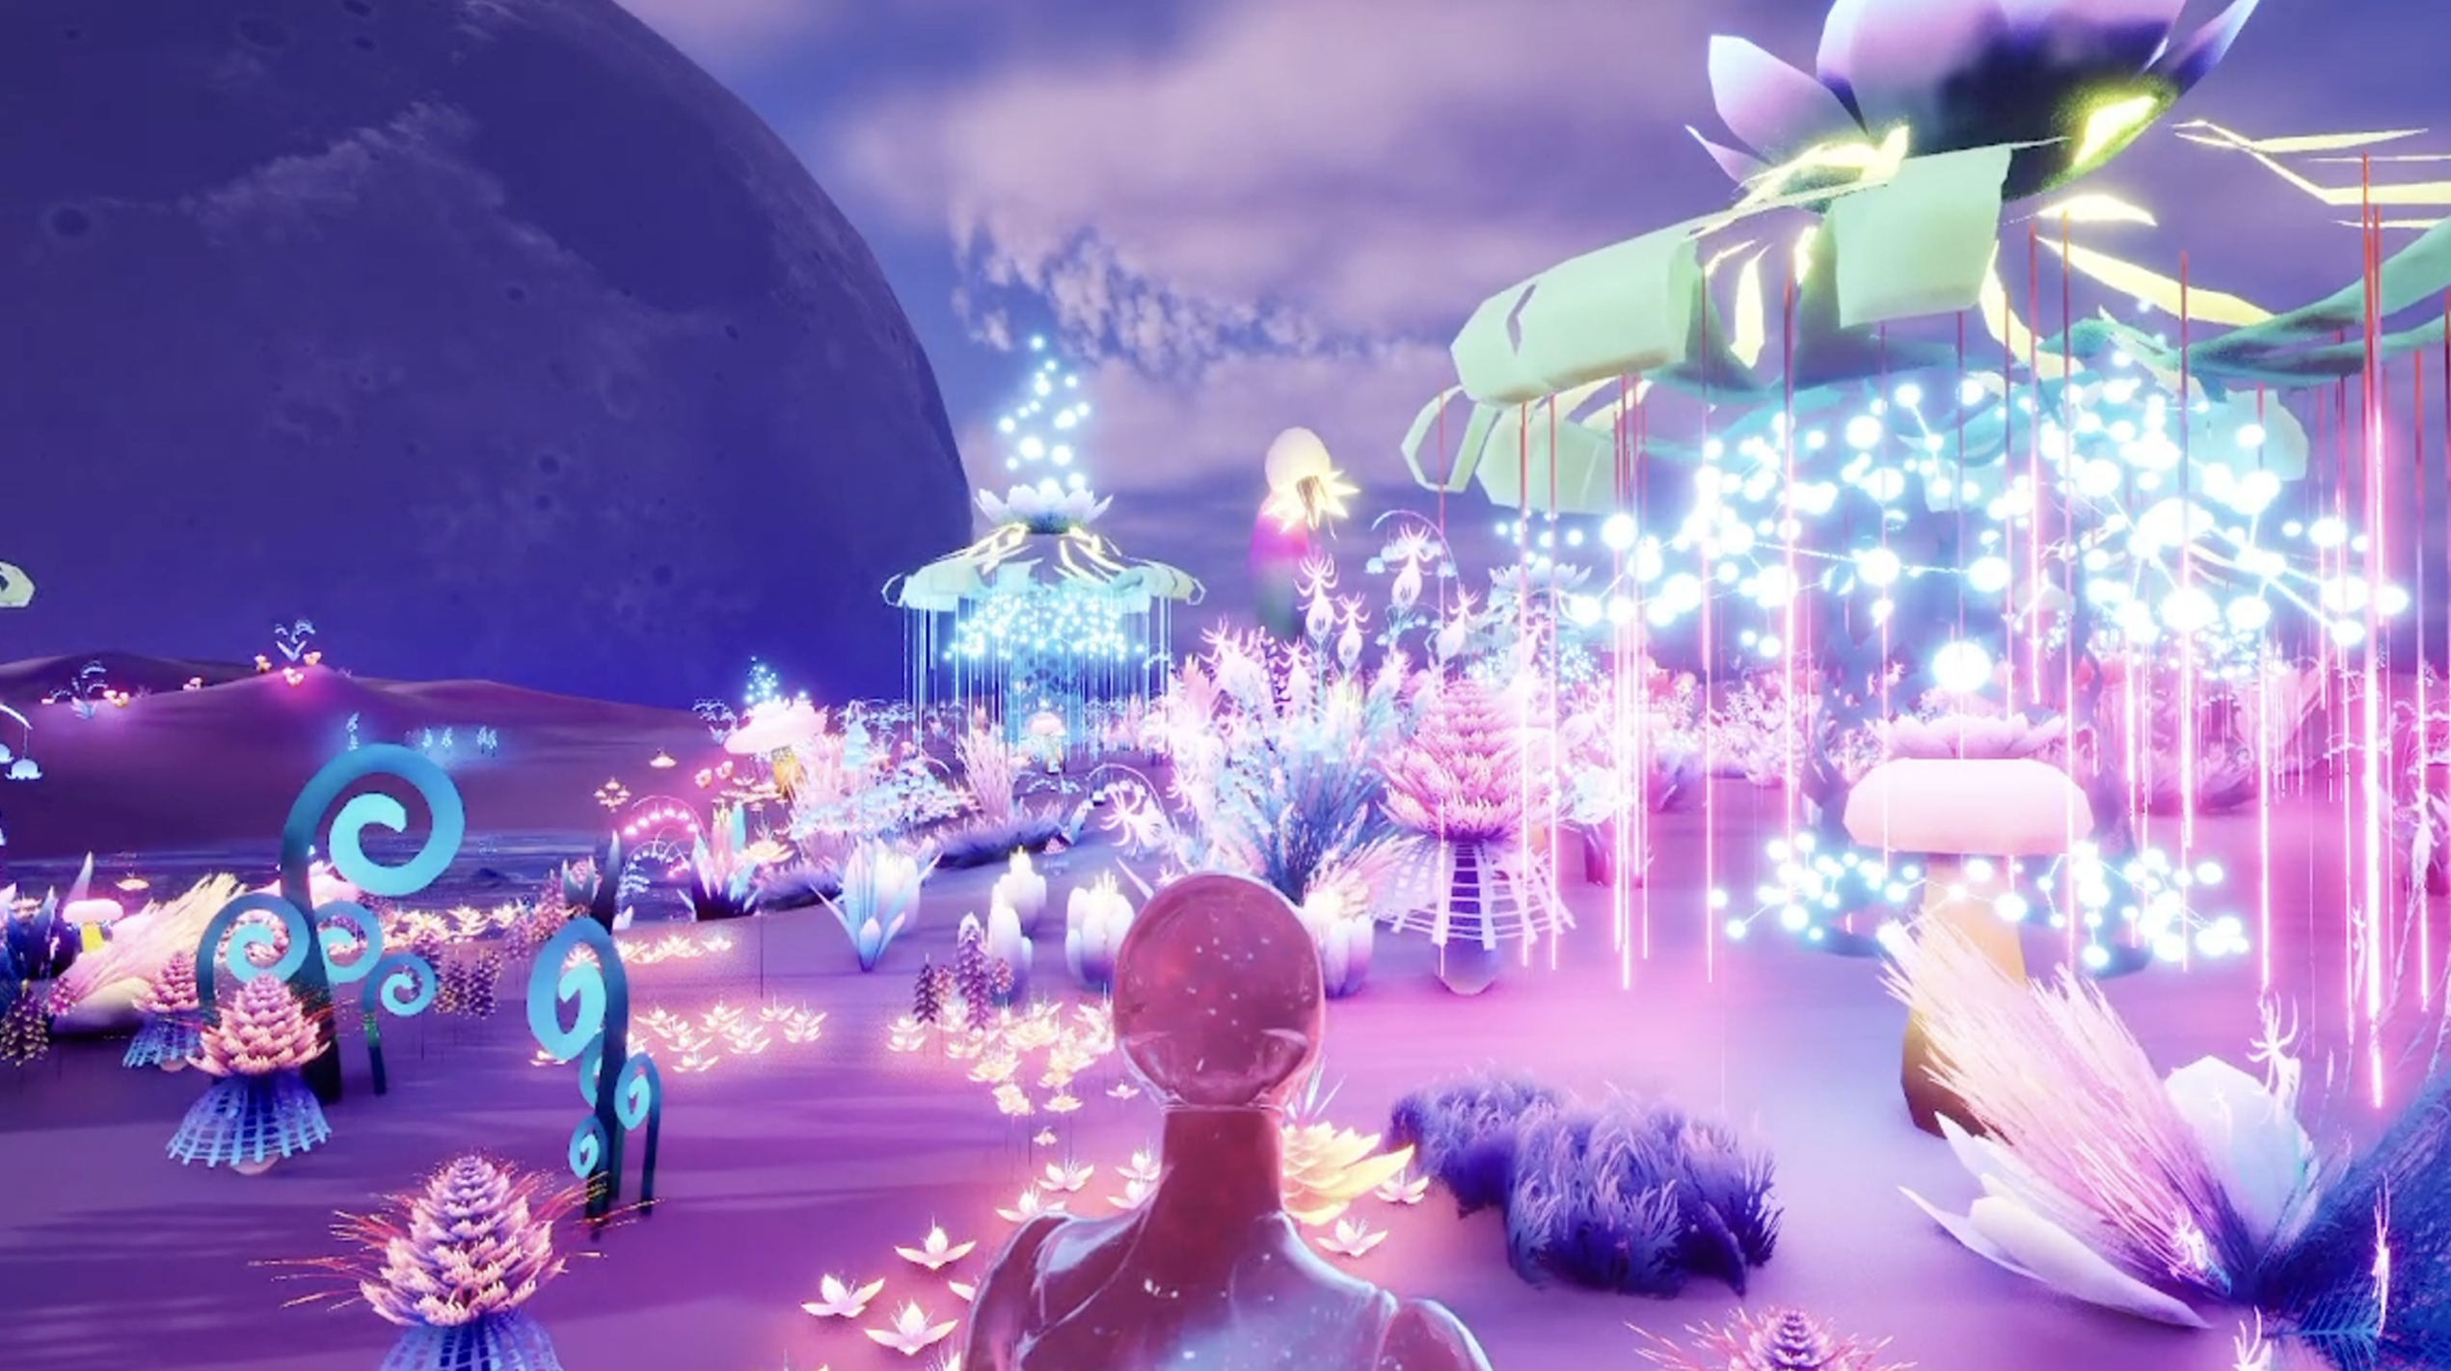

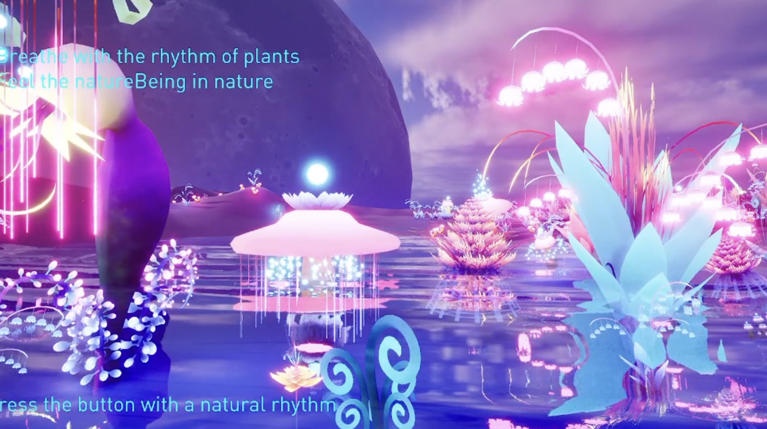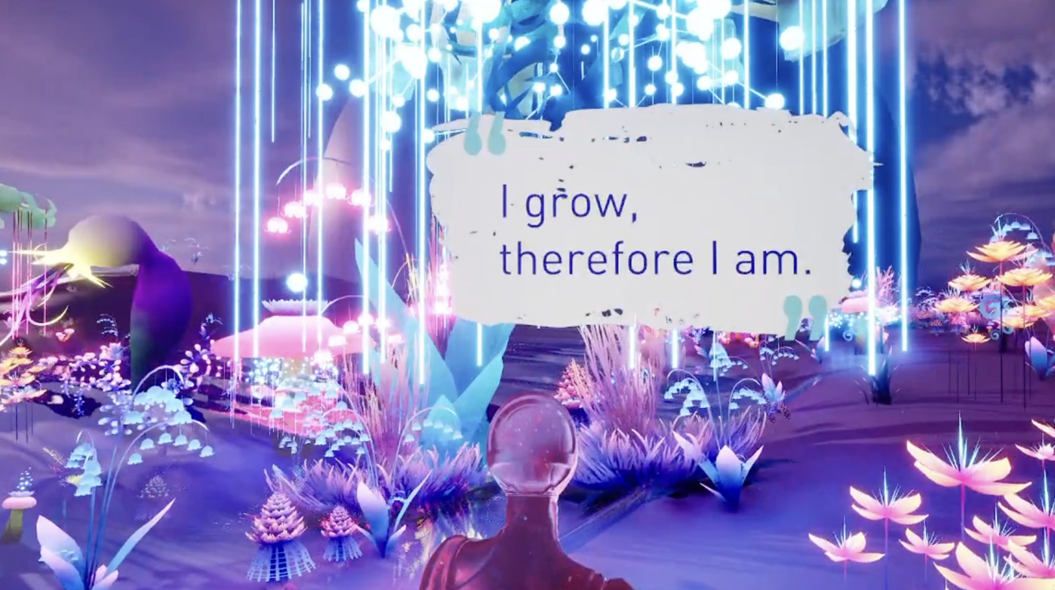

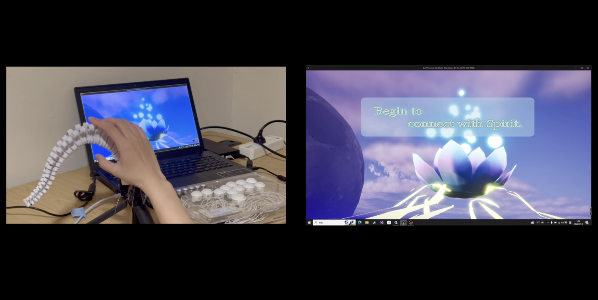

**Documentation of playtest results：**

https://docs.google.com/spreadsheets/d/1aqiNN0otXgbEoBRp28wp7VezbPhOZ_W-Wu8nM-uod_c/edit?usp=sharing

**Gameplay homework reflection:**

I've always been a big fan of Chen Xinghan's games, and most of his works are weak on language while conveying delicate emotions and unparalleled experiences through game visual design and plot design. When I entered the world of Journey, I was completely captivated by the game's landscapes, as well as its minimalist visuals and evocative soundtrack. The game guides the player on an almost spiritual journey of discovery and connection through "zen-like" visuals and sounds.

I place a great deal of emphasis on spiritual and mindful experiences in my games, and so in my Final Project I also encourage players to think about the intimate and important connections we have with the living world.

**Link to Sprint 1 Report:**

https://pie-clipper-2a5.notion.site/Sprint-Report-1-30f7622dec6144d6a424950e79cf5e92?pvs=4

**Link to Sprint 2 Report:**

<https://pie-clipper-2a5.notion.site/Sprint-Report-1-abbe03bc70154db2a7520ae07d80766e?pvs=4>